## First Implementation

## Method

* Pretrain a resnet56 baseline to a level as good as possible.
* Pruning the network using the criteria:
  + Random method without constraint
  + Random method with constraint of 70±2.5% sparsity
  + TPE method without constraint
  + TPE method with constraint of 70±2.5% sparsity

## Train a resnet56 Baseline Model

### Command

|  |
| --- |
| python3 ../classifier_compression/compress_classifier.py --arch resnet56_cifar --lr 0.03 -p 50 ../../../data.cifar10 -b 128 -j 1 --vs 0.1 --deterministic --epochs 200 --compress=./resnet56_cifar_baseline.yaml |

### YAML File

*lr_schedulers:*

*training_lr:*

*class: MultiStepMultiGammaLR*

*milestones: [5, 10, 20, 30, 50, 150]*

*gammas: [0.7, 0.5, 0.5, 0.5, 0.5, 0.5]*

*policies:*

*- lr_scheduler:*

*instance_name: training_lr*

*starting_epoch: 0*

*ending_epoch: 560*

*frequency: 1*

### Training Result

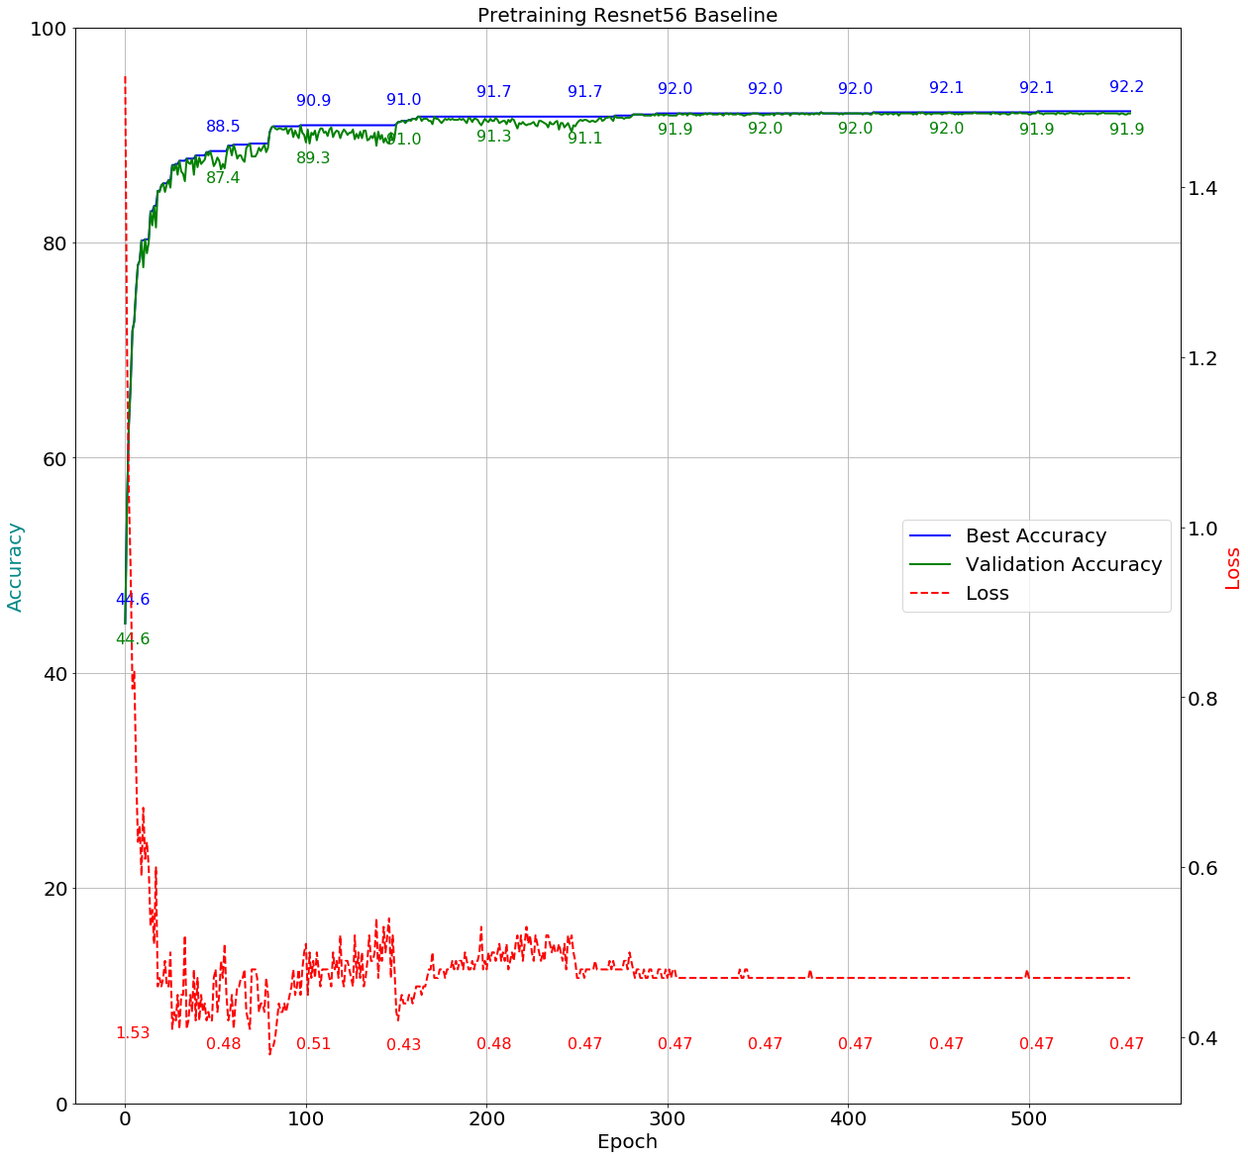

## Search Space

The search space is the uniform distribution between minimum value and maximum value on each convolutional weight.

def get_space():

space = {}

for name, parameter in model.named_parameters():

if 'conv' in name and 'weight' in name:

space[name] = hp.uniform(name, 0.30, 0.99)

return space

## Score Function

score = (1-(val_accuracy/100.)) + (alpha * (1-sparsity/100.))

## Suggest Method

For TPE:

best = fmin(objective, space, algo=tpe.suggest, max_evals=args.rounds)

For Random:

best = fmin(objective, space, algo=hyperopt.rand.suggest, max_evals=args.rounds)

## Pruning Result

### Random method without constraint

|  |
| --- |
| python auto.py --arch resnet56_cifar --gpus=0 --lr=0.003 ../../../data.cifar10 -b=128 -j=1 --deterministic --resume='./pertrain base line/2018.11.08-213504/best.pth.tar' --rounds=20 --epochs=30 --method=’random’ |

round:1, score:0.1329, train_acc:99.2178, val_acc:97.5400, test_acc:90.3700, sparsity:63.4339  
round:2, score:0.1397, train_acc:99.2000, val_acc:96.9200, test_acc:90.0700, sparsity:63.6942  
round:3, score:0.1390, train_acc:99.2111, val_acc:97.5600, test_acc:90.0100, sparsity:61.5247  
round:4, score:0.1428, train_acc:98.5911, val_acc:95.2600, test_acc:90.0000, sparsity:65.9488  
round:5, score:0.1333, train_acc:98.7778, val_acc:96.1600, test_acc:90.1200, sparsity:67.9112  
round:6, score:0.1291, train_acc:99.5467, val_acc:97.8800, test_acc:90.7800, sparsity:63.3144  
round:7, score:0.1315, train_acc:99.5200, val_acc:97.8000, test_acc:90.5300, sparsity:62.8851  
round:8, score:0.1456, train_acc:99.5111, val_acc:98.2200, test_acc:89.8900, sparsity:57.4099  
round:9, score:0.1288, train_acc:99.0044, val_acc:96.9600, test_acc:89.9700, sparsity:67.1856  
round:10, score:0.1292, train_acc:99.6444, val_acc:98.2200, test_acc:90.6200, sparsity:62.0543  
round:11, score:0.1221, train_acc:99.2667, val_acc:97.1200, test_acc:90.3000, sparsity:68.3670  
round:12, score:0.1345, train_acc:99.4578, val_acc:97.8400, test_acc:90.7100, sparsity:62.3675  
round:13, score:0.1497, train_acc:99.1933, val_acc:96.9400, test_acc:90.2200, sparsity:59.3125  
round:14, score:0.1459, train_acc:99.1444, val_acc:96.5000, test_acc:90.3800, sparsity:61.4334  
round:15, score:0.1333, train_acc:98.9800, val_acc:96.3800, test_acc:90.1100, sparsity:67.6239  
round:16, score:0.1347, train_acc:99.4556, val_acc:97.6200, test_acc:90.1300, sparsity:62.4456  
round:17, score:0.1341, train_acc:99.5222, val_acc:97.8800, test_acc:90.2900, sparsity:62.0389  
round:18, score:0.1298, train_acc:99.2333, val_acc:96.8400, test_acc:90.1000, sparsity:65.4029  
round:19, score:0.1240, train_acc:99.3911, val_acc:97.6200, test_acc:90.2000, sparsity:66.3396  
round:20, score:0.1339, train_acc:99.2667, val_acc:97.1600, test_acc:90.2900, sparsity:62.8307

’module.conv1.weight': 0.519453534851879,  
’module.layer1.0.conv1.weight': 0.601271639735327,  
’module.layer1.0.conv2.weight': 0.726769891797648,  
’module.layer1.1.conv1.weight': 0.508005745340092,  
’module.layer1.1.conv2.weight': 0.758294720818404,  
’module.layer1.2.conv1.weight': 0.646381526901049,  
’module.layer1.2.conv2.weight': 0.937157476348435,  
’module.layer1.3.conv1.weight': 0.767553787554462,  
’module.layer1.3.conv2.weight': 0.76934172597243,  
’module.layer1.4.conv1.weight': 0.763386259515083,  
’module.layer1.4.conv2.weight': 0.908742731915059,  
’module.layer1.5.conv1.weight': 0.805953997682668,  
’module.layer1.5.conv2.weight': 0.379755691920525,  
’module.layer1.6.conv1.weight': 0.368141891071684,  
’module.layer1.6.conv2.weight': 0.343499338701901,  
’module.layer1.7.conv1.weight': 0.393293204931277,  
’module.layer1.7.conv2.weight': 0.595538741654875,  
’module.layer1.8.conv1.weight': 0.525133091388918,  
’module.layer1.8.conv2.weight': 0.695164216626768,  
’module.layer2.0.conv1.weight': 0.472049933125105,  
’module.layer2.0.conv2.weight': 0.386504612864878,  
’module.layer2.1.conv1.weight': 0.914350048478572,  
’module.layer2.1.conv2.weight': 0.397557517400476,  
’module.layer2.2.conv1.weight': 0.379297200027578,  
’module.layer2.2.conv2.weight': 0.920091448446573,  
’module.layer2.3.conv1.weight': 0.972311697355797,  
’module.layer2.3.conv2.weight': 0.690845119425622,  
’module.layer2.4.conv1.weight': 0.920073490319871,  
’module.layer2.4.conv2.weight': 0.615004502439158,  
’module.layer2.5.conv1.weight': 0.798276007973996,  
’module.layer2.5.conv2.weight': 0.985300850012866,  
’module.layer2.6.conv1.weight': 0.586577168162162,  
’module.layer2.6.conv2.weight': 0.550362174640348,  
’module.layer2.7.conv1.weight': 0.826528166270262,  
’module.layer2.7.conv2.weight': 0.391337063866534,  
’module.layer2.8.conv1.weight': 0.521855154043542,  
’module.layer2.8.conv2.weight': 0.539052580992194,  
’module.layer3.0.conv1.weight': 0.574417946579844,  
’module.layer3.0.conv2.weight': 0.840507684201953,  
’module.layer3.1.conv1.weight': 0.725209367141896,  
’module.layer3.1.conv2.weight': 0.886489269126627,  
’module.layer3.2.conv1.weight': 0.724017752889759,  
’module.layer3.2.conv2.weight': 0.300666443850314,  
’module.layer3.3.conv1.weight': 0.903523709266426,  
’module.layer3.3.conv2.weight': 0.464714018583245,  
’module.layer3.4.conv2.weight': 0.570831766815719,  
’module.layer3.5.conv1.weight': 0.743720363557057,  
’module.layer3.5.conv2.weight': 0.744680627513436,  
’module.layer3.6.conv1.weight': 0.886918610669229,  
’module.layer3.6.conv2.weight': 0.839630135202238,  
’module.layer3.7.conv1.weight': 0.545559014171576,  
’module.layer3.7.conv2.weight': 0.562193763806044,  
’module.layer3.8.conv1.weight': 0.481831252331312,  
’module.layer3.8.conv2.weight': 0.934626398180086,  
‘module.layer3.4.conv1.weight': 0.717924244814645,

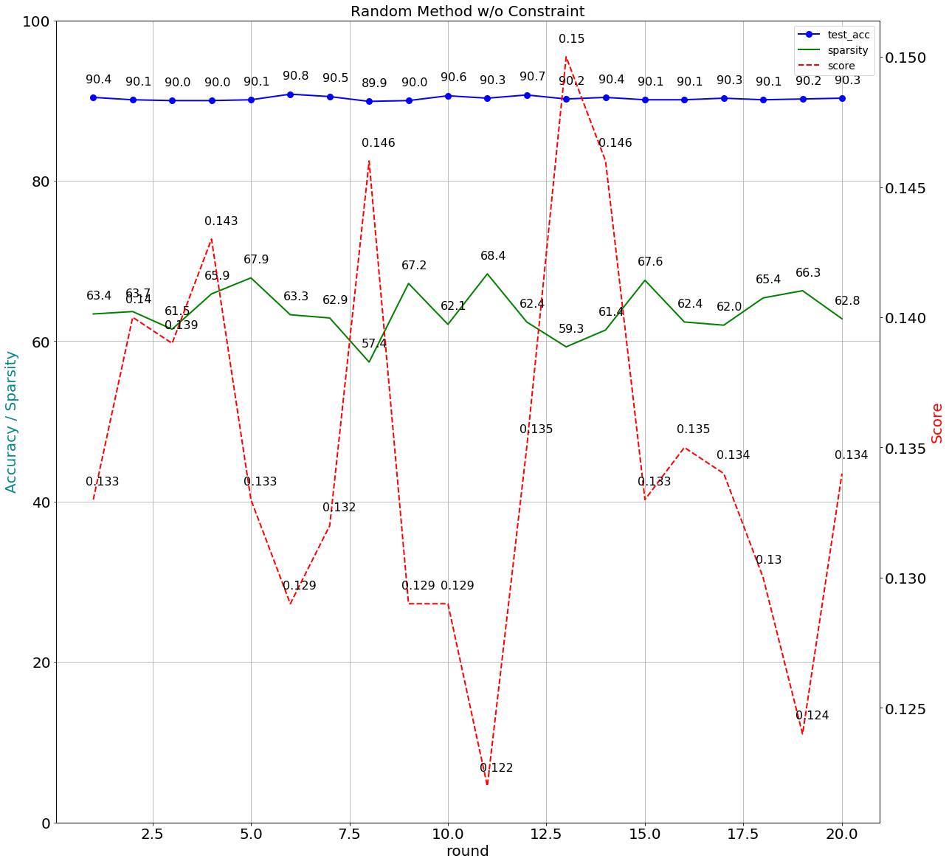

### Random method with constraint of 70±2.5% sparsity

|  |
| --- |
| python auto.py --arch resnet56_cifar --gpus=0 --lr=0.003 ../../../data.cifar10 -b=128 -j=1 --deterministic --resume='./pertrain base line/2018.11.08-213504/best.pth.tar' --rounds=20 --epochs=30 --method=’random’ --pruner-constraint |

round:1, score:0.1645, train_acc:91.4511, val_acc:93.5800, test_acc:88.2200, sparsity:66.5504  
round:2, score:0.2011, train_acc:89.0778, val_acc:92.6400, test_acc:86.9400, sparsity:57.5066  
round:3, score:0.1676, train_acc:92.9022, val_acc:95.2800, test_acc:88.7800, sparsity:59.8809  
round:4, score:0.1566, train_acc:94.2422, val_acc:95.9200, test_acc:88.5700, sparsity:61.4135  
round:5, score:0.1747, train_acc:92.0444, val_acc:94.1800, test_acc:88.4200, sparsity:61.1647  
round:6, score:0.1752, train_acc:88.4511, val_acc:92.3200, test_acc:87.2300, sparsity:67.2153  
round:7, score:0.1759, train_acc:92.1822, val_acc:94.6600, test_acc:88.4100, sparsity:59.1565  
round:8, score:0.1444, train_acc:95.2178, val_acc:96.6200, test_acc:89.2400, sparsity:63.1227  
round:9, score:0.2006, train_acc:88.6067, val_acc:91.5600, test_acc:86.8200, sparsity:61.2630  
round:10, score:0.1539, train_acc:92.2044, val_acc:94.5600, test_acc:88.3500, sparsity:66.8386  
round:11, score:0.1585, train_acc:91.5978, val_acc:94.3400, test_acc:87.7700, sparsity:66.0233  
round:12, score:0.1715, train_acc:90.4511, val_acc:93.2200, test_acc:87.1500, sparsity:65.4194  
round:13, score:0.1564, train_acc:91.9178, val_acc:94.1600, test_acc:88.0500, sparsity:67.3181  
round:14, score:0.1497, train_acc:92.7689, val_acc:95.0400, test_acc:88.4800, sparsity:66.6444  
round:15, score:0.1152, train_acc:98.9000, val_acc:96.6000, test_acc:90.3800, sparsity:72.1488  
round:16, score:0.1879, train_acc:91.4178, val_acc:92.5400, test_acc:87.0300, sparsity:62.2461  
round:17, score:0.1554, train_acc:92.5511, val_acc:94.7200, test_acc:88.1800, sparsity:65.7879  
round:18, score:0.1340, train_acc:98.8422, val_acc:95.8800, test_acc:89.8200, sparsity:67.9245  
round:19, score:0.1711, train_acc:91.4289, val_acc:94.5800, test_acc:88.4100, sparsity:61.0408  
round:20, score:0.1574, train_acc:92.8156, val_acc:94.8800, test_acc:88.8300, sparsity:64.5942

‘module.conv1.weight': 0.906957785929862,  
‘module.layer1.0.conv1.weight': 0.326796506341287,  
‘module.layer1.0.conv2.weight': 0.846398861018247,  
‘module.layer1.1.conv1.weight': 0.84533834417431,  
‘module.layer1.1.conv2.weight': 0.489599625347857,  
‘module.layer1.2.conv1.weight': 0.3435984722888,  
‘module.layer1.2.conv2.weight': 0.775349634247014,  
‘module.layer1.3.conv1.weight': 0.660027847705321,  
‘module.layer1.3.conv2.weight': 0.405484578959248,  
‘module.layer1.4.conv1.weight': 0.684085323094024,  
‘module.layer1.4.conv2.weight': 0.580759493177218,  
‘module.layer1.5.conv1.weight': 0.792632410740443,  
‘module.layer1.5.conv2.weight': 0.434046149274458,  
‘module.layer1.6.conv1.weight': 0.675729759703671,  
‘module.layer1.6.conv2.weight': 0.783211679910042,  
‘module.layer1.7.conv1.weight': 0.935708394829227,  
‘module.layer1.7.conv2.weight': 0.401720611171903,  
‘module.layer1.8.conv1.weight': 0.500830930153686,  
‘module.layer1.8.conv2.weight': 0.355737348044877,  
‘module.layer2.0.conv1.weight': 0.941925888522003,  
‘module.layer2.0.conv2.weight': 0.455280907435438,  
‘module.layer2.1.conv1.weight': 0.718546590315616,  
‘module.layer2.1.conv2.weight': 0.732413919670848,  
‘module.layer2.2.conv1.weight': 0.617701686995196,  
‘module.layer2.2.conv2.weight': 0.623592830554754,  
‘module.layer2.3.conv1.weight': 0.851018665793473,  
‘module.layer2.3.conv2.weight': 0.336900943081801,  
‘module.layer2.4.conv1.weight': 0.609943863136227,  
'module.layer2.4.conv2.weight': 0.327545881052538,  
‘module.layer2.5.conv1.weight': 0.755912537582466,  
‘module.layer2.5.conv2.weight': 0.300216150608542,  
‘module.layer2.6.conv1.weight': 0.447068219324498,  
‘module.layer2.6.conv2.weight': 0.858982744969615,  
‘module.layer2.7.conv1.weight': 0.548628940887679,  
‘module.layer2.7.conv2.weight': 0.346923473882068,  
‘module.layer2.8.conv1.weight': 0.979553238973532,  
‘module.layer2.8.conv2.weight': 0.955200089147754,  
‘module.layer3.0.conv1.weight': 0.750567483899369,  
‘module.layer3.0.conv2.weight': 0.833317773191016,  
‘module.layer3.1.conv1.weight': 0.799399440599761,  
‘module.layer3.1.conv2.weight': 0.621054440673115,  
‘module.layer3.2.conv1.weight': 0.568551543026765,  
‘module.layer3.2.conv2.weight': 0.601257045189569,  
‘module.layer3.3.conv1.weight': 0.955131451386637,  
‘module.layer3.3.conv2.weight': 0.855316557550849,  
‘module.layer3.4.conv1.weight': 0.765216557745791,  
‘module.layer3.4.conv2.weight': 0.734353016590695,  
‘module.layer3.5.conv1.weight': 0.483217672352786,  
‘module.layer3.5.conv2.weight': 0.940586614836248,  
‘module.layer3.6.conv1.weight': 0.313836980644055,  
‘module.layer3.6.conv2.weight': 0.983817708659908,  
‘module.layer3.7.conv1.weight': 0.909327867847061,  
‘module.layer3.7.conv2.weight': 0.825570975564672,  
‘module.layer3.8.conv1.weight': 0.947950635327218,  
‘module.layer3.8.conv2.weight': 0.730800428932419,

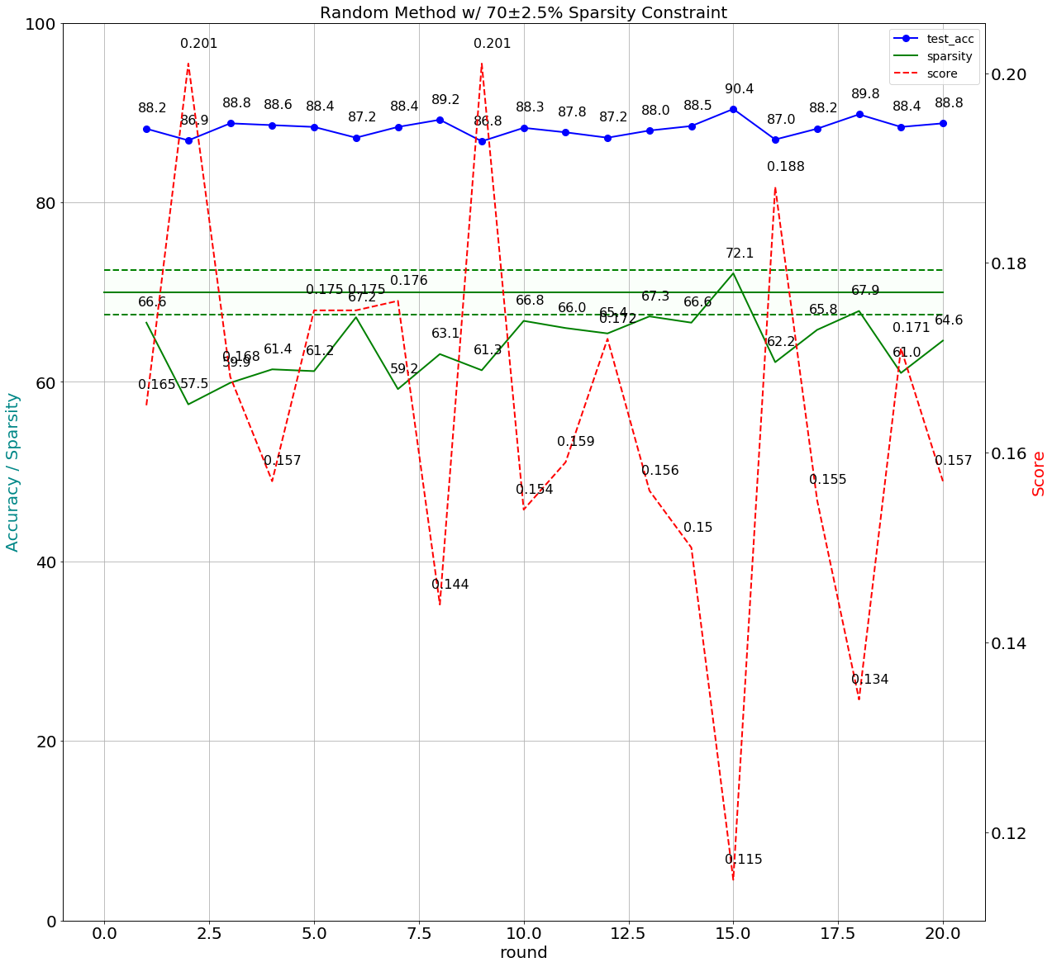

### TPE method without constraint

|  |
| --- |
| python auto.py --arch resnet56_cifar --gpus=0 --lr=0.003 ../../../data.cifar10 -b=128 -j=1 --deterministic --resume='./pertrain base line/2018.11.08-213504/best.pth.tar' --rounds=20 --epochs=30 --method=’tpe’ |

round:1, score:0.1250, train_acc:99.6578, val_acc:97.9800, test_acc:90.5200, sparsity:63.3868  
round:2, score:0.1214, train_acc:99.2489, val_acc:97.1000, test_acc:90.4100, sparsity:68.9222  
round:3, score:0.1284, train_acc:99.3200, val_acc:97.5600, test_acc:90.0800, sparsity:65.3271  
round:4, score:0.1541, train_acc:98.7867, val_acc:96.4400, test_acc:90.1400, sparsity:59.4185  
round:5, score:0.1394, train_acc:99.6600, val_acc:98.5200, test_acc:90.5300, sparsity:58.4627  
round:6, score:0.1358, train_acc:99.4089, val_acc:97.2000, test_acc:90.5900, sparsity:62.8610  
round:7, score:0.1365, train_acc:99.2667, val_acc:97.2600, test_acc:90.5400, sparsity:63.0949  
round:8, score:0.1289, train_acc:99.2022, val_acc:97.2000, test_acc:90.0800, sparsity:66.1005  
round:9, score:0.1333, train_acc:98.7867, val_acc:96.6000, test_acc:89.5800, sparsity:66.8992  
round:10, score:0.1418, train_acc:99.6622, val_acc:97.9600, test_acc:90.4300, sparsity:57.6561  
round:11, score:0.1308, train_acc:99.6756, val_acc:98.3000, test_acc:90.5700, sparsity:61.5354  
round:12, score:0.1165, train_acc:98.0978, val_acc:95.4200, test_acc:89.9500, sparsity:75.8952  
round:13, score:0.1343, train_acc:99.5933, val_acc:98.1800, test_acc:90.4500, sparsity:59.9705  
round:14, score:0.1268, train_acc:99.3889, val_acc:97.5600, test_acc:90.4000, sparsity:65.6596  
round:15, score:0.1221, train_acc:99.3422, val_acc:97.6200, test_acc:90.5400, sparsity:66.6363  
round:16, score:0.1381, train_acc:99.7467, val_acc:98.5200, test_acc:90.4900, sparsity:57.9126  
round:17, score:0.1313, train_acc:99.2244, val_acc:97.2400, test_acc:90.2200, sparsity:65.4473  
round:18, score:0.1328, train_acc:98.5089, val_acc:95.8000, test_acc:89.9600, sparsity:69.7375  
round:19, score:0.1192, train_acc:99.3600, val_acc:97.3400, test_acc:90.3300, sparsity:68.5837  
round:20, score:0.1337, train_acc:99.5911, val_acc:97.9400, test_acc:90.6500, sparsity:61.2959

‘module.conv1.weight': 0.868803883740578,  
‘module.layer1.0.conv1.weight': 0.847789658066599,  
‘module.layer1.0.conv2.weight': 0.574262829428587,  
‘module.layer1.1.conv1.weight': 0.392838908394838,  
‘module.layer1.1.conv2.weight': 0.680772868968364,  
‘module.layer1.2.conv1.weight': 0.944061828783238,  
‘module.layer1.2.conv2.weight': 0.905331099352333,  
‘module.layer1.3.conv1.weight': 0.806255849987785,  
‘module.layer1.3.conv2.weight': 0.561129289872814,  
‘module.layer1.4.conv1.weight': 0.80870261405486,  
‘module.layer1.4.conv2.weight': 0.494439995536961,  
‘module.layer1.5.conv1.weight': 0.907794705131917,  
‘module.layer1.5.conv2.weight': 0.673254583352526,  
‘module.layer1.6.conv1.weight': 0.932986084663167,  
‘module.layer1.6.conv2.weight': 0.761617052260549,  
‘module.layer1.7.conv1.weight': 0.547482128369246,  
‘module.layer1.7.conv2.weight': 0.699383705527818,  
‘module.layer1.8.conv1.weight': 0.899599497588079,  
‘module.layer1.8.conv2.weight': 0.380596443607256,  
‘module.layer2.0.conv1.weight': 0.542018286462394,  
‘module.layer2.0.conv2.weight': 0.779463219134289,  
‘module.layer2.1.conv1.weight': 0.686097140833618,  
‘module.layer2.1.conv2.weight': 0.526496910263335,  
‘module.layer2.2.conv1.weight': 0.343402055615396,  
‘module.layer2.2.conv2.weight': 0.839446047866604,  
‘module.layer2.3.conv1.weight': 0.821880369099761,  
'module.layer2.3.conv2.weight': 0.726773437911085,  
‘module.layer2.4.conv1.weight': 0.760749743114005,  
‘module.layer2.4.conv2.weight': 0.855588601189668,  
‘module.layer2.5.conv1.weight': 0.653141249648415,  
‘module.layer2.5.conv2.weight': 0.677469203391921,  
‘module.layer2.6.conv1.weight': 0.881792294234138,  
‘module.layer2.6.conv2.weight': 0.970271867851428,  
‘module.layer2.7.conv1.weight': 0.577934191090879,  
‘module.layer2.7.conv2.weight': 0.807236660616409,  
‘module.layer2.8.conv1.weight': 0.562945173426366,  
‘module.layer2.8.conv2.weight': 0.794507914223084,  
‘module.layer3.0.conv1.weight': 0.633372452157346,  
‘module.layer3.0.conv2.weight': 0.961327722069813,  
‘module.layer3.1.conv1.weight': 0.69362934055276,  
‘module.layer3.1.conv2.weight': 0.729874360314567,  
‘module.layer3.2.conv1.weight': 0.935577549770274,  
‘module.layer3.2.conv2.weight': 0.618159617557541,  
‘module.layer3.3.conv1.weight': 0.65537874423706,  
‘module.layer3.3.conv2.weight': 0.902453270508724,  
‘module.layer3.4.conv1.weight': 0.462919919275933,  
‘module.layer3.4.conv2.weight': 0.620307351161171,  
‘module.layer3.5.conv1.weight': 0.946742021222744,  
‘module.layer3.5.conv2.weight': 0.785683598242341,  
‘module.layer3.6.conv1.weight': 0.878266822408936,  
‘module.layer3.6.conv2.weight': 0.978773204613939,  
‘module.layer3.7.conv1.weight': 0.757007521384302,  
‘module.layer3.7.conv2.weight': 0.896653749518336,  
‘module.layer3.8.conv1.weight': 0.472719983269247,  
‘module.layer3.8.conv2.weight': 0.973763667266204,

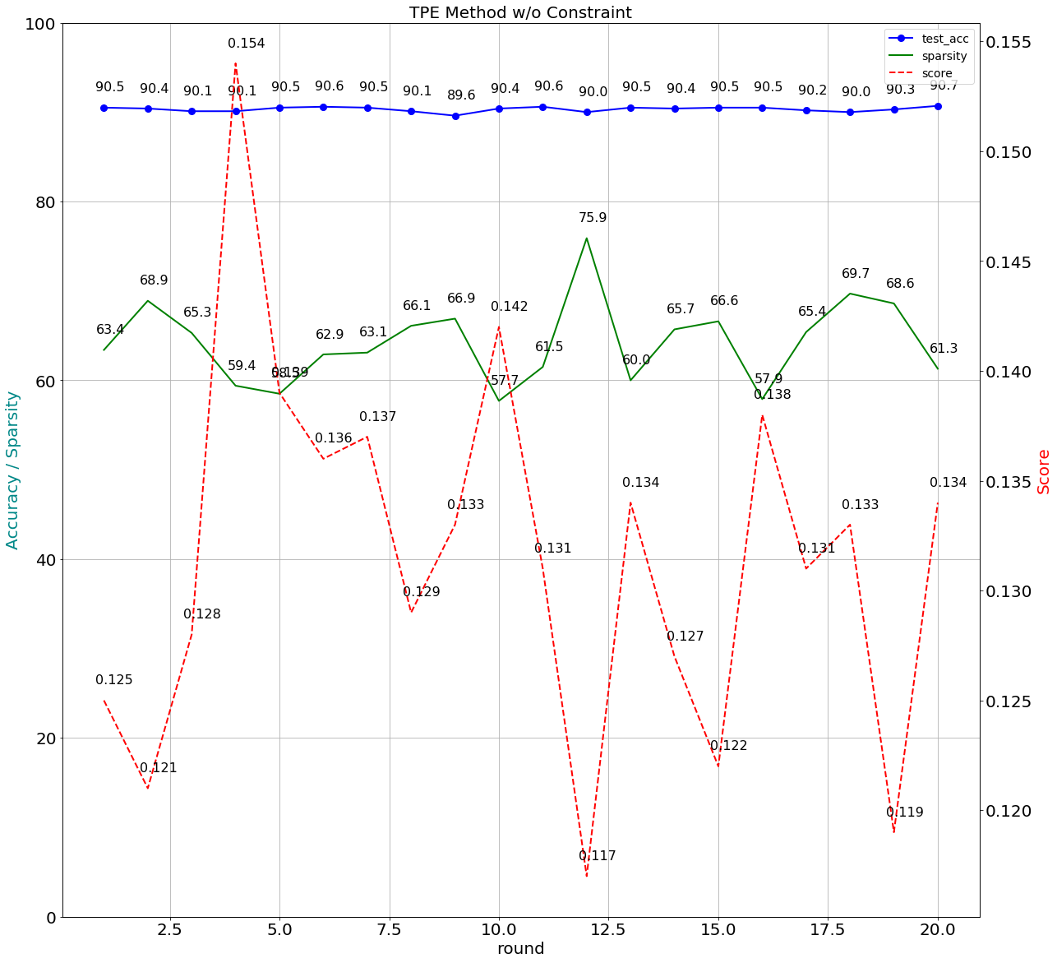

### TPE method with constraint of 70±2.5% sparsity

|  |
| --- |
| python auto.py --arch resnet56_cifar --gpus=0 --lr=0.03 ../../../data.cifar10 -b=128 -j=1 --deterministic --resume='./pertrain base line/2018.11.12-210049/best.pth.tar' --rounds=20 --epochs=20 --method=tpe --pruner-constraint |

round:1, score:0.1535, train_acc:92.5667, val_acc:94.7400, test_acc:88.1000, sparsity:66.3634  
round:2, score:0.1888, train_acc:87.6733, val_acc:91.8800, test_acc:86.6000, sparsity:64.1261  
round:3, score:0.2123, train_acc:82.1822, val_acc:88.7400, test_acc:84.5100, sparsity:66.7591  
round:4, score:0.1523, train_acc:92.8400, val_acc:95.7200, test_acc:88.3900, sparsity:63.4922  
round:5, score:0.1908, train_acc:87.8933, val_acc:92.3800, test_acc:87.0800, sparsity:61.7990  
round:6, score:0.1702, train_acc:91.5444, val_acc:93.7000, test_acc:87.2700, sparsity:64.2736  
round:7, score:0.1793, train_acc:88.6244, val_acc:92.6400, test_acc:87.3000, sparsity:64.7719  
round:8, score:0.1388, train_acc:94.4311, val_acc:96.3400, test_acc:88.8200, sparsity:65.9181  
round:9, score:0.1591, train_acc:92.4044, val_acc:94.9600, test_acc:88.4700, sparsity:63.7628  
round:10, score:0.1657, train_acc:91.4022, val_acc:94.6000, test_acc:88.0300, sparsity:62.7523  
round:11, score:0.1156, train_acc:99.6956, val_acc:97.1600, test_acc:90.1500, sparsity:68.3384  
round:12, score:0.1795, train_acc:91.3956, val_acc:94.0600, test_acc:87.7200, sparsity:59.9692  
round:13, score:0.1647, train_acc:91.2689, val_acc:94.9400, test_acc:88.1900, sparsity:61.9591  
round:14, score:0.1624, train_acc:93.7533, val_acc:96.2000, test_acc:88.5700, sparsity:58.5260  
round:15, score:0.2224, train_acc:82.6756, val_acc:88.3600, test_acc:84.7200, sparsity:64.6548  
round:16, score:0.1472, train_acc:94.2289, val_acc:96.0400, test_acc:88.4400, sparsity:64.1218  
round:17, score:0.1759, train_acc:89.8044, val_acc:93.5600, test_acc:87.1200, sparsity:62.8186

‘module.conv1.weight': 0.498775841148591,  
‘module.layer1.0.conv1.weight': 0.851414562718911,  
‘module.layer1.0.conv2.weight': 0.191314114784789,  
‘module.layer1.1.conv1.weight': 0.878179117364064,  
‘module.layer1.1.conv2.weight': 0.51522309849354,  
‘module.layer1.2.conv1.weight': 0.89392584263347,  
‘module.layer1.2.conv2.weight': 0.633952902240188,  
‘module.layer1.3.conv1.weight': 0.91672235662212,  
‘module.layer1.3.conv2.weight': 0.822525927620518,  
‘module.layer1.4.conv1.weight': 0.925430459774281,  
‘module.layer1.4.conv2.weight': 0.0374609799121243,  
‘module.layer1.5.conv1.weight': 0.286095419799372,  
‘module.layer1.5.conv2.weight': 0.44288127741843,  
‘module.layer1.6.conv1.weight': 0.873420372245792,  
‘module.layer1.6.conv2.weight': 0.651433321901078,  
‘module.layer1.7.conv1.weight': 0.107739230425684,  
‘module.layer1.7.conv2.weight': 0.946693765902945,  
‘module.layer1.8.conv1.weight': 0.241864107941752,  
‘module.layer1.8.conv2.weight': 0.621881652697629,  
‘module.layer2.0.conv1.weight': 0.834728391946025,  
‘module.layer2.0.conv2.weight': 0.509128606201432,  
‘module.layer2.1.conv1.weight': 0.302084662379377,  
‘module.layer2.1.conv2.weight': 0.370861991679644,  
‘module.layer2.2.conv1.weight': 0.233955018746964,  
‘module.layer2.2.conv2.weight': 0.579624557558419,  
‘module.layer2.3.conv1.weight': 0.750318832664843,  
‘module.layer2.3.conv2.weight': 0.694026373138848,  
‘module.layer2.4.conv1.weight': 0.0747055063269187,  
‘module.layer2.4.conv2.weight': 0.485257308590196,  
‘module.layer2.5.conv1.weight': 0.881231861785112,  
‘module.layer2.5.conv2.weight': 0.204359009938375,  
‘module.layer2.6.conv1.weight': 0.848518681238732,  
‘module.layer2.6.conv2.weight': 0.929941251534044,  
‘module.layer2.7.conv1.weight': 0.915616750724122,  
‘module.layer2.7.conv2.weight': 0.21819395933601,  
‘module.layer2.8.conv1.weight': 0.491796788656375,  
‘module.layer2.8.conv2.weight': 0.779708715125794,  
‘module.layer3.0.conv1.weight': 0.474080568874371,  
‘module.layer3.0.conv2.weight': 0.610143430745419,  
‘module.layer3.1.conv1.weight': 0.461582617476816,  
‘module.layer3.1.conv2.weight': 0.52042652940282,  
‘module.layer3.2.conv1.weight': 0.916363432986558,  
‘module.layer3.2.conv2.weight': 0.424169051911123,  
‘module.layer3.3.conv1.weight': 0.392011117698078,  
‘module.layer3.3.conv2.weight': 0.247932260806036,  
‘module.layer3.4.conv1.weight': 0.466589411144595,  
‘module.layer3.4.conv2.weight': 0.881303139191081,  
‘module.layer3.5.conv1.weight': 0.974922864103847,  
‘module.layer3.5.conv2.weight': 0.767357319726048,  
‘module.layer3.6.conv1.weight': 0.0853981292582127,  
‘module.layer3.6.conv2.weight': 0.190372060612402,  
‘module.layer3.7.conv1.weight': 0.151529233650744,  
‘module.layer3.7.conv2.weight': 0.695678522742824,  
‘module.layer3.8.conv1.weight': 0.857640961753601,  
‘module.layer3.8.conv2.weight': 0.150235196440312,

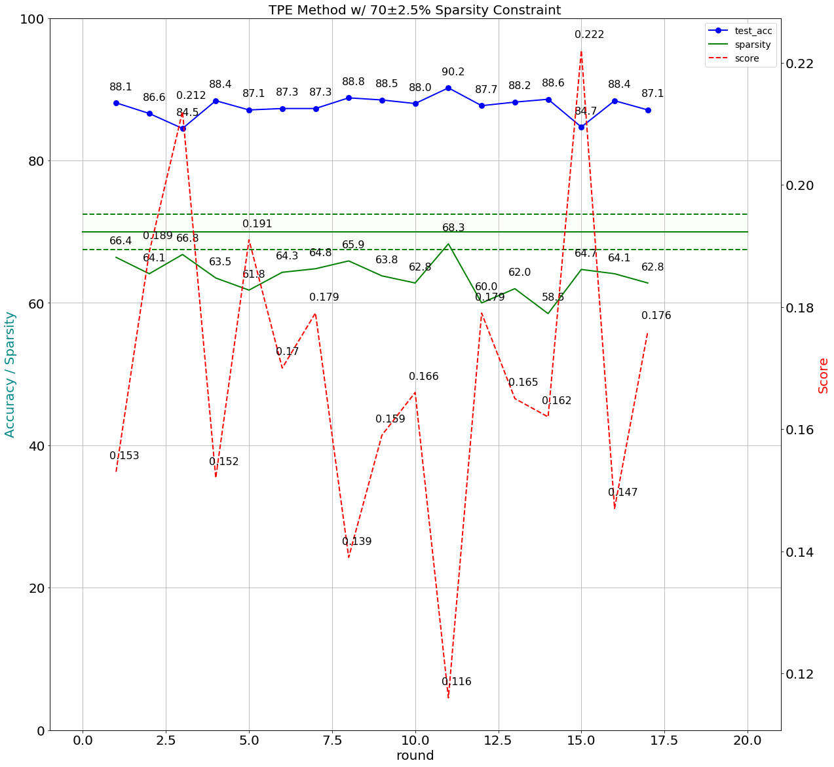

# Second Implementation

* Build the baseline model

This procedure was as same as the first one, but the YAML file was just using the StepLR policies and listed below

*lr_schedulers:*

*training_lr:*

*class: StepLR*

*step_size: 45*

*gamma: 0.10*

*policies:*

*- lr_scheduler:*

*instance_name: training_lr*

*starting_epoch: 45*

*ending_epoch: 200*

*frequency: 1*

The best top1 accuracy was 93.1% on epoch 195. Of course, the sparsity was 0.0%. Baseline model was saved in ‘./logs/2018.11.10-021811/best.pth.tar’

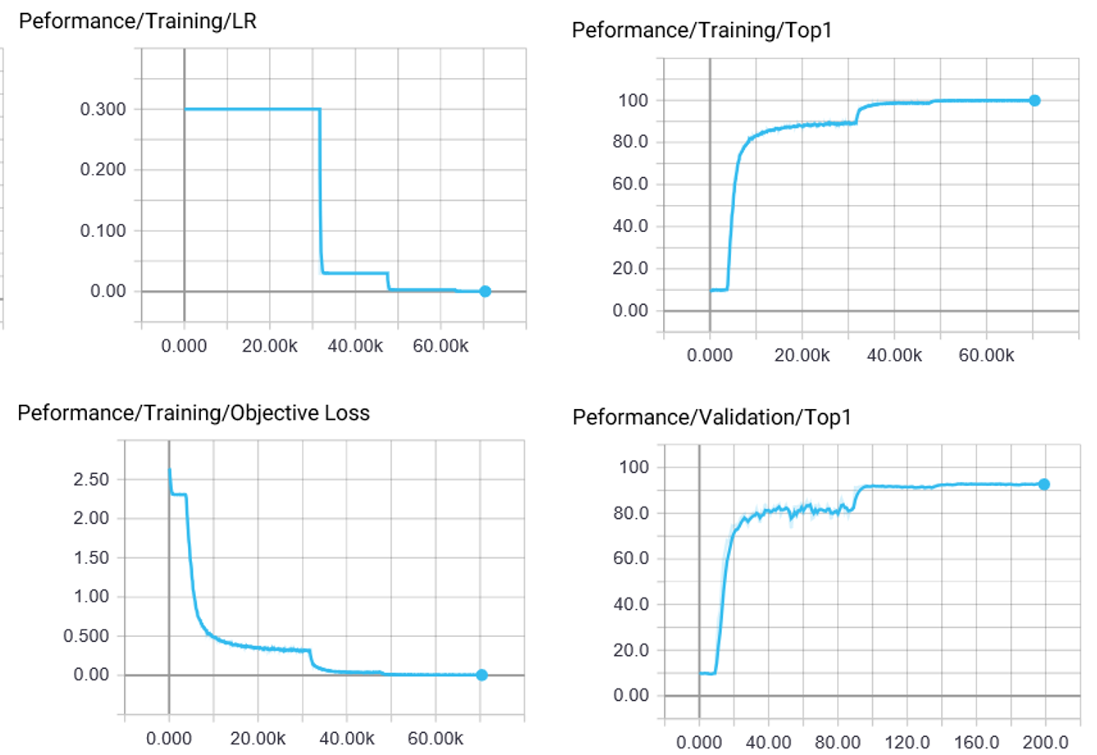

* Search Space

Define the search space was the sparsity of the weights of all the FC and CONV layers. min_v and max_v were the minimal and maximal value with uniform distribution of the sparsities. max_v was always less than 1 and near to 1. If the sparsity constraint was 70%, min_v would be 0.7 or higher. Otherwise, if there was no sparsity constraint, min_v would be 0.

*def get_space(min_v, max_v):*

*space = {}*

*for name, parameter in model.named_parameters():*

*if 'conv' in name and 'weight' in name or 'fc' in name and 'weight' in name:*

*space[name] = hp.uniform(name, min_v, max_v)*

*return space*

* Score function

There were two Interdependent parameters, sparsity and accuracy. The optimization strategy was getting as high as possible sparsity and the accuracy is higher than 90%.

And the score function would be

*score = -((val_accuracy/100.)**2-0.9**2 + alpha * ((sparsity/100.)**2-0.5**2))*

alpha was the weight of these two parameters. In this experiment, alpha was setting to 1.

* Training procedure

There were four cases, randomization algorithm *tpe.suggest* and *rand.suggest* with and without sparsity constraint.

*#Tpe + constraint*

*main(0.7, 0.99, tpe.suggest)*

*#Random + constraint*

*main(0.7, 0.99, rand.suggest)*

*#Tpe + no constraint*

*main(0.1, 0.99, tpe.suggest)*

*#Random + no constraint*

*main(0.1, 0.99, rand.suggest)*

Each case ran 20 epoches and 30 rounds. The command was

*python LAB4-2.py --epochs=20 -r=30 --resume='./logs/2018.11.10-021811/best.pth.tar'*

* Training results

The case of tpe.suggest with constraint

===========================================

The best accuracy and sparsity is occurred by:

trials :27

score :-0.5759

train acc :96.13%

val acc :94.54%

test acc :93.92%

sparsity :86.14%

module.conv1.weight : 0.7895

module.fc.weight : 0.7639

module.layer1.0.conv1.weight : 0.9797

module.layer1.0.conv2.weight : 0.8745

module.layer1.1.conv1.weight : 0.9539

module.layer1.1.conv2.weight : 0.8849

module.layer1.2.conv1.weight : 0.9800

module.layer1.2.conv2.weight : 0.8898

module.layer1.3.conv1.weight : 0.8104

module.layer1.3.conv2.weight : 0.9857

module.layer1.4.conv1.weight : 0.8776

module.layer1.4.conv2.weight : 0.9426

module.layer1.5.conv1.weight : 0.8687

module.layer1.5.conv2.weight : 0.9778

module.layer1.6.conv1.weight : 0.7361

module.layer1.6.conv2.weight : 0.7532

module.layer1.7.conv1.weight : 0.8093

module.layer1.7.conv2.weight : 0.7250

module.layer1.8.conv1.weight : 0.7295

module.layer1.8.conv2.weight : 0.7157

module.layer2.0.conv1.weight : 0.9154

module.layer2.0.conv2.weight : 0.8121

module.layer2.1.conv1.weight : 0.7593

module.layer2.1.conv2.weight : 0.7991

module.layer2.2.conv1.weight : 0.9250

module.layer2.2.conv2.weight : 0.8930

module.layer2.3.conv1.weight : 0.9544

module.layer2.3.conv2.weight : 0.7855

module.layer2.4.conv1.weight : 0.9438

module.layer2.4.conv2.weight : 0.7055

module.layer2.5.conv1.weight : 0.7925

module.layer2.5.conv2.weight : 0.7860

module.layer2.6.conv1.weight : 0.8248

module.layer2.6.conv2.weight : 0.7994

module.layer2.7.conv1.weight : 0.9143

module.layer2.7.conv2.weight : 0.7744

module.layer2.8.conv1.weight : 0.9603

module.layer2.8.conv2.weight : 0.7458

module.layer3.0.conv1.weight : 0.8060

module.layer3.0.conv2.weight : 0.8725

module.layer3.1.conv1.weight : 0.8552

module.layer3.1.conv2.weight : 0.8656

module.layer3.2.conv1.weight : 0.7762

module.layer3.2.conv2.weight : 0.9084

module.layer3.3.conv1.weight : 0.8798

module.layer3.3.conv2.weight : 0.8519

module.layer3.4.conv1.weight : 0.8062

module.layer3.4.conv2.weight : 0.8479

module.layer3.5.conv1.weight : 0.9816

module.layer3.5.conv2.weight : 0.8229

module.layer3.6.conv1.weight : 0.7111

module.layer3.6.conv2.weight : 0.8610

module.layer3.7.conv1.weight : 0.9690

module.layer3.7.conv2.weight : 0.9896

module.layer3.8.conv1.weight : 0.9153

module.layer3.8.conv2.weight : 0.9325

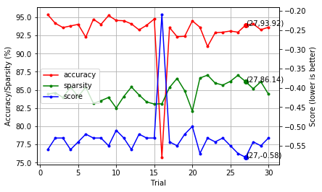

The case of rand.suggest with constraint

===========================================

The best accuracy and sparsity is occurred by:

trials :18

score :-0.5835

train acc :95.20%

val acc :92.54%

test acc :92.28%

sparsity :88.72%

module.conv1.weight : 0.7776

module.fc.weight : 0.8970

module.layer1.0.conv1.weight : 0.8344

module.layer1.0.conv2.weight : 0.9175

module.layer1.1.conv1.weight : 0.8889

module.layer1.1.conv2.weight : 0.7183

module.layer1.2.conv1.weight : 0.9101

module.layer1.2.conv2.weight : 0.9079

module.layer1.3.conv1.weight : 0.9879

module.layer1.3.conv2.weight : 0.7057

module.layer1.4.conv1.weight : 0.8514

module.layer1.4.conv2.weight : 0.8985

module.layer1.5.conv1.weight : 0.7277

module.layer1.5.conv2.weight : 0.8572

module.layer1.6.conv1.weight : 0.9812

module.layer1.6.conv2.weight : 0.9329

module.layer1.7.conv1.weight : 0.8755

module.layer1.7.conv2.weight : 0.9558

module.layer1.8.conv1.weight : 0.9781

module.layer1.8.conv2.weight : 0.9408

module.layer2.0.conv1.weight : 0.7302

module.layer2.0.conv2.weight : 0.7648

module.layer2.1.conv1.weight : 0.9433

module.layer2.1.conv2.weight : 0.9273

module.layer2.2.conv1.weight : 0.9013

module.layer2.2.conv2.weight : 0.9510

module.layer2.3.conv1.weight : 0.9154

module.layer2.3.conv2.weight : 0.9534

module.layer2.4.conv1.weight : 0.8810

module.layer2.4.conv2.weight : 0.8259

module.layer2.5.conv1.weight : 0.7444

module.layer2.5.conv2.weight : 0.9813

module.layer2.6.conv1.weight : 0.8816

module.layer2.6.conv2.weight : 0.9252

module.layer2.7.conv1.weight : 0.8375

module.layer2.7.conv2.weight : 0.7573

module.layer2.8.conv1.weight : 0.8446

module.layer2.8.conv2.weight : 0.8013

module.layer3.0.conv1.weight : 0.7369

module.layer3.0.conv2.weight : 0.9233

module.layer3.1.conv1.weight : 0.9066

module.layer3.1.conv2.weight : 0.9610

module.layer3.2.conv1.weight : 0.8966

module.layer3.2.conv2.weight : 0.7625

module.layer3.3.conv1.weight : 0.9080

module.layer3.3.conv2.weight : 0.9378

module.layer3.4.conv1.weight : 0.8813

module.layer3.4.conv2.weight : 0.9783

module.layer3.5.conv1.weight : 0.8324

module.layer3.5.conv2.weight : 0.9604

module.layer3.6.conv1.weight : 0.9062

module.layer3.6.conv2.weight : 0.9734

module.layer3.7.conv1.weight : 0.8846

module.layer3.7.conv2.weight : 0.8520

module.layer3.8.conv1.weight : 0.9358

module.layer3.8.conv2.weight : 0.8090

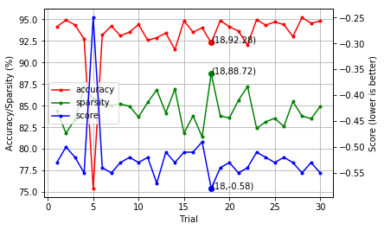

The case of tpe.suggest without constraint

===========================================

The best accuracy and sparsity is occurred by:

trials :20

score :-0.2657

train acc :97.60%

val acc :95.78%

test acc :95.86%

sparsity :63.90%

module.conv1.weight : 0.9370

module.fc.weight : 0.1123

module.layer1.0.conv1.weight : 0.4538

module.layer1.0.conv2.weight : 0.7014

module.layer1.1.conv1.weight : 0.4281

module.layer1.1.conv2.weight : 0.5650

module.layer1.2.conv1.weight : 0.3714

module.layer1.2.conv2.weight : 0.1742

module.layer1.3.conv1.weight : 0.6974

module.layer1.3.conv2.weight : 0.7587

module.layer1.4.conv1.weight : 0.1171

module.layer1.4.conv2.weight : 0.5168

module.layer1.5.conv1.weight : 0.1576

module.layer1.5.conv2.weight : 0.1587

module.layer1.6.conv1.weight : 0.8939

module.layer1.6.conv2.weight : 0.5503

module.layer1.7.conv1.weight : 0.8929

module.layer1.7.conv2.weight : 0.4923

module.layer1.8.conv1.weight : 0.7034

module.layer1.8.conv2.weight : 0.2777

module.layer2.0.conv1.weight : 0.5722

module.layer2.0.conv2.weight : 0.4510

module.layer2.1.conv1.weight : 0.8902

module.layer2.1.conv2.weight : 0.9800

module.layer2.2.conv1.weight : 0.7725

module.layer2.2.conv2.weight : 0.3761

module.layer2.3.conv1.weight : 0.2478

module.layer2.3.conv2.weight : 0.9426

module.layer2.4.conv1.weight : 0.8435

module.layer2.4.conv2.weight : 0.9246

module.layer2.5.conv1.weight : 0.9034

module.layer2.5.conv2.weight : 0.3818

module.layer2.6.conv1.weight : 0.6839

module.layer2.6.conv2.weight : 0.8532

module.layer2.7.conv1.weight : 0.7384

module.layer2.7.conv2.weight : 0.5213

module.layer2.8.conv1.weight : 0.4331

module.layer2.8.conv2.weight : 0.1610

module.layer3.0.conv1.weight : 0.9362

module.layer3.0.conv2.weight : 0.2133

module.layer3.1.conv1.weight : 0.4460

module.layer3.1.conv2.weight : 0.8533

module.layer3.2.conv1.weight : 0.9893

module.layer3.2.conv2.weight : 0.3674

module.layer3.3.conv1.weight : 0.9032

module.layer3.3.conv2.weight : 0.7727

module.layer3.4.conv1.weight : 0.4253

module.layer3.4.conv2.weight : 0.4637

module.layer3.5.conv1.weight : 0.5036

module.layer3.5.conv2.weight : 0.7766

module.layer3.6.conv1.weight : 0.7453

module.layer3.6.conv2.weight : 0.9881

module.layer3.7.conv1.weight : 0.2252

module.layer3.7.conv2.weight : 0.8423

module.layer3.8.conv1.weight : 0.8976

module.layer3.8.conv2.weight : 0.4628

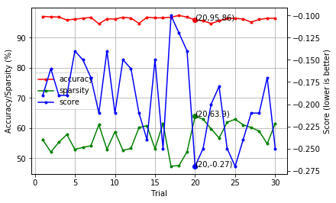

The case of rand.suggest without constraint

===========================================

The best accuracy and sparsity is occurred by:

trials :10

score :-0.2465

train acc :98.17%

val acc :95.80%

test acc :96.26%

sparsity :62.35%

module.conv1.weight : 0.1293

module.fc.weight : 0.2342

module.layer1.0.conv1.weight : 0.1409

module.layer1.0.conv2.weight : 0.3423

module.layer1.1.conv1.weight : 0.3039

module.layer1.1.conv2.weight : 0.7220

module.layer1.2.conv1.weight : 0.5978

module.layer1.2.conv2.weight : 0.4936

module.layer1.3.conv1.weight : 0.6383

module.layer1.3.conv2.weight : 0.9051

module.layer1.4.conv1.weight : 0.4139

module.layer1.4.conv2.weight : 0.5391

module.layer1.5.conv1.weight : 0.1048

module.layer1.5.conv2.weight : 0.7531

module.layer1.6.conv1.weight : 0.1417

module.layer1.6.conv2.weight : 0.4241

module.layer1.7.conv1.weight : 0.9791

module.layer1.7.conv2.weight : 0.5851

module.layer1.8.conv1.weight : 0.3300

module.layer1.8.conv2.weight : 0.1471

module.layer2.0.conv1.weight : 0.6467

module.layer2.0.conv2.weight : 0.9783

module.layer2.1.conv1.weight : 0.5493

module.layer2.1.conv2.weight : 0.8116

module.layer2.2.conv1.weight : 0.5126

module.layer2.2.conv2.weight : 0.4778

module.layer2.3.conv1.weight : 0.1325

module.layer2.3.conv2.weight : 0.7142

module.layer2.4.conv1.weight : 0.7432

module.layer2.4.conv2.weight : 0.8882

module.layer2.5.conv1.weight : 0.3783

module.layer2.5.conv2.weight : 0.2084

module.layer2.6.conv1.weight : 0.2061

module.layer2.6.conv2.weight : 0.9044

module.layer2.7.conv1.weight : 0.2546

module.layer2.7.conv2.weight : 0.2484

module.layer2.8.conv1.weight : 0.8758

module.layer2.8.conv2.weight : 0.3500

module.layer3.0.conv1.weight : 0.7044

module.layer3.0.conv2.weight : 0.4056

module.layer3.1.conv1.weight : 0.8055

module.layer3.1.conv2.weight : 0.7078

module.layer3.2.conv1.weight : 0.3490

module.layer3.2.conv2.weight : 0.6563

module.layer3.3.conv1.weight : 0.2188

module.layer3.3.conv2.weight : 0.9267

module.layer3.4.conv1.weight : 0.8811

module.layer3.4.conv2.weight : 0.9674

module.layer3.5.conv1.weight : 0.2417

module.layer3.5.conv2.weight : 0.7765

module.layer3.6.conv1.weight : 0.1243

module.layer3.6.conv2.weight : 0.9185

module.layer3.7.conv1.weight : 0.3753

module.layer3.7.conv2.weight : 0.9708

module.layer3.8.conv1.weight : 0.8950

module.layer3.8.conv2.weight : 0.8998

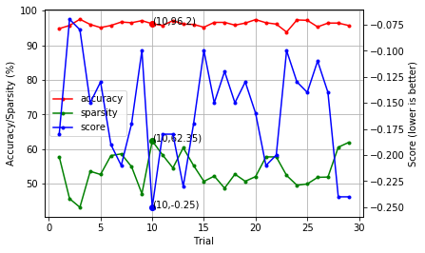

* Q&A

1. Explain how you deal with constraints

* Search space
* Objective function

2. Compare with different algorithms

* Draw and explain the Pareto curve

The Pareto curves were shown below.

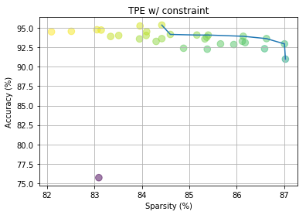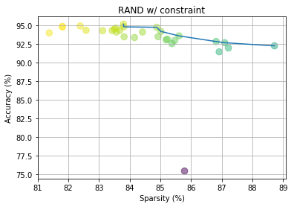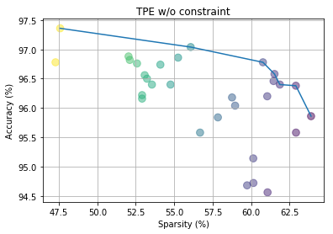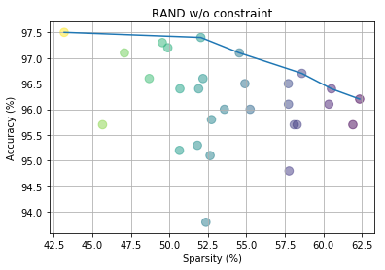

3. Give a global constraint

* Can hyper-parameters optimization easily fit constraints?
* Can human-design space easily cover all possibility?

4. How do we avoid curse of dimensionality with the increase of the number of layers?

# 

# 